Payroll Module

Main Database
Shift
Leave Opening
Employee
Master
Details

Holiday Calendar
Activity Calendar

Table of Contents

Requirements Analysis
Systems Characteristics
Integration with Other Modules
User Pre-Requisites
Getting Started
Setups
- Shift Master .........................................................................................................
- Shift Schedule ………………………………………………………………………………………………….
- Modifying Employee Shift ………………………………………………………………………………….
- Activity Calendar ……………………………………………………………………………………………..
- Holiday Calendar ……………………………………………………………………………………………..
- Leave Opening ……………………………………………………………………………………………….
- PF Profit …………………………………………………………………………………………………………
- Professional Tax ……………………………………………………………………………………………..
- Prior Year WPPF ……………………………………………………………………………………………..
Transactions
- Time In ………………………………………………………………………………………………………….
- Time Out ……………………………………………………………………………………………………….
- Approved Overtime ………………………………………………………………………………………..
- Short Leave …………………………………………………………………………………………………..
- Leave Approval ……………………………………………………………………………………………..
- Suspend Penalizing ………………………… …………………………………………………………….
- Additional Department Cost …………………………………………………………………………….
- Payroll …………………………………………………………………………………………………………
- Increment and Arrear …………………………………………………………………………………….
- Full & Final Settlement ………………………….……………………………………………………….
Reports
- Department Listing …………………………………………………………………………………………
- Designation Listing …………………………………………………………………………………………
- Grade Listing …………………………………………………………………………………………………
- Payment Mode Listing …………………………………………………………………………………….
- HR Master Listing …………………………………………………………………………………………...
- Salary Master Listing ………………………………………………………………………………………
- Shift Master Listing ………………………………………………………………………………………..
- Shift Schedule Listing …………………………………………………………………………………….
- Modifying Employee Shift Listing ……………………………………………………………………..
- Activity Calendar Listing …………………………………………………………………………………
- Holiday Calendar Listing …………………………………………………………………………………
- Leave Opening Listing ……………………………………………………………………………………
- PF Profit Listing …………………………………………………………………………………………….
- Professional Tax Listing ………………………………………………………………………………….
- Prior Year WPPF Listing …………………………………………………………………………………
- ATTENDANCE Log ……………………………………………………………………………………………………….
- Transaction Log ……………………………………………………………………………………………
- Documents …………………………………………………………………………………………………..
- Attendance Listing …………………………………………………………………………………………
- Absents Listing ………………………………………………………………………………………………
- Leave Application Form …………………………………………………………………………………..
- Register ………………………………………………………………………………………………………..
- Leave Card ……………………………………………………………………………………………………
- Additional Department Cost ……………………………………………………………………………
- Payroll Listing ………………………………………………………………………………………………..
- Increment Letter ……………………………………………………………………………………………
- SESSI Listing …………………………………………………………………………………………………
- EOBI Listing ………………………………………………………………………………………………….
- WPPF Listing …………………………………………………………………………………………………
- Witholding Tax Listing ……………………………………………………………………………………
- Ledger ………………………………………………………………………………………………………….
- Statistical Return …………………………………………………………………………………………..
- UPL Reports ………………………………………………………………………………………………….

Utility Tools
- Auditing Process ……………………………………………………………………………………………
- Posting Process …………………………………………………………………………………………….
- Un-posting Process ……………………………………………………………………………………….
- ATTENDANCE - Attendance Generation ………………………………………………………………………..
- Payroll Generation ………………………………………………………………………………………..
- Payroll Processing …………………………………………………………………………………………
- Arrear Processing …………………………………………………………………………………………
- Full & Final Processing ………………………………………………………………………………….
- SESSI Processing …………………………………………………………………………………………
- EOBI Processing ……………………………………………………………………………………………
- WPPF Processing …………………………………………………………………………………………..
- Encashment Generation ………………………………………………………………………………..
- Yearly Closing ………………………………………………………………………………………………
- Backup Data File ………………………………………………………………………………………….
- Restore Data File ………………………………………………………………………………………….

Security
- System Policy ……………………………………………………………………………………………….
- Group Access Right ………………………………………………………………………………………
- User Access Right …………………………………………………………………………………………
- Transaction Auditing ……………………………………………………………………………………..
- View User Activity ………………………………………………………………………………………….

Requirements Analysis
Systems Characteristics
Integration with Other Modules

Payroll Module is linked with the following FCL modules:

PY PF

HR
Dependency Diagram
- Human Resource -HR
- Provident Fund Trust -PF

Payroll module uses HR Employee master file. But it maintains its own database for the relevant kind of information about FCL employees with the reference of ‘employee code’; hence, the HR database remains unaffected (exception: Full & Final Settlement Transaction of Payroll; see bellow).

Relationship with HR Module

- Full & Final Settlement by Payroll module modifies an employee’s master file by tagging it as ‘Full & Final Settled’ ; this tag has the following impacts:
1) Full & Final Settlement transaction in Payroll module is only possible when the selected employee is not flagged ‘Full & Final Settled’
- Specifying an employee’s ‘Date Left’ in the FCL HR Module has the following impacts on Payroll Module:
1) the employee becomes a right candidate for Full & Final Settlement by Payroll module
2) the employee is no longer eligible for other attendance and payroll transactions; obviously, because he/she has left the FCL job

Relationship with Provident Fund Module

- In its JV Generation Process, FCL PF-Financial Module gathers all kinds of necessary information about Provident Fund Trust members employed by FCL and generates a Journal Voucher worth as per their ‘last processed payroll’.
- JV Generation Process leaves this tags the relevant members’ payroll transactions that their JV has been generated; JV Deletion Process does vice versa.

User Pre-Requisites
Getting Started

Setup
_______________________________________________________________________________

FLC Payroll Module’s Setup files are data entry screens for the following database entities:

- Shifts
- Yearly Calendars
- Employee’s Leave Opening
- Taxation and Funds

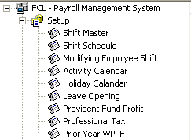 | 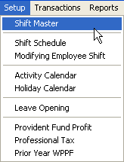

In the subsequent pages, each Setup entry is described briefly with the help of screen-shots.

Shift Master
_______________________________________________________________________________

Description
This form helps define details of different shifts; such as ‘Off-Days’, ‘Time-In’, ‘Time-Out’, ‘Break-Hours’ and ‘Standard Working Hours’. FCL defines working days into three categories: Standard, Friday, Half-Day or Holiday. Based on the selected shift, the system generates an ‘Activity Calendar’ for 365 financial year days behind the scene, deleting the old calendar (if any) of that particular shift so that only new rescheduled settings apply on the shift.

Note that:
- There are some special checks for each shift; namely, Grace Time, Late Coming and Early Going; which helps the system decide how an employee’s attendance should be treated; e.g. Is it a half day or not ?
- The nature of the shift (Fixed or Rotate) is there for the FCL Attendance Machine processing method:
- For a Fixed Shift , the FCL Attendance Machine Terminal throws ‘fixed’ timing parameters as specified in the Shift Master settings
- For a Rotate Shift , the FCL Attendance Machine Terminal identifies the time (In or Out) with the shift currently going and saves away the attendance data as such

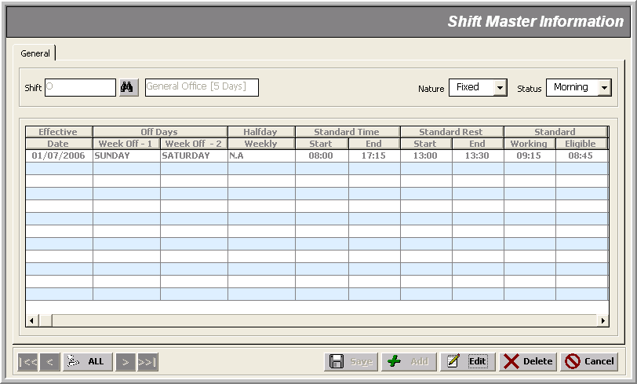

Shift Schedule
_______________________________________________________________________________

Description
Here we schedule employee’s shifts on weekly basis.

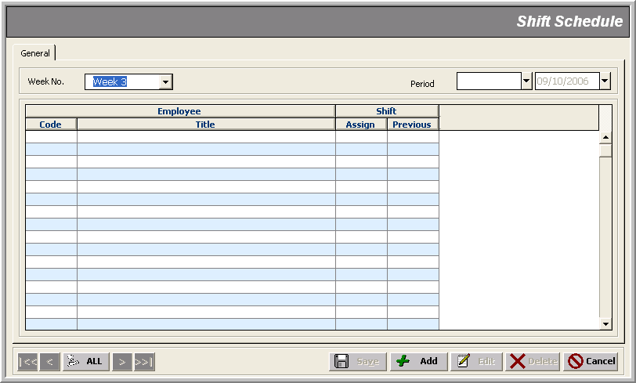

Modifying Employee Shift
_______________________________________________________________________________

Description
Here an administrator uses his right to change an employee’s shift.
Note that:
- We modify an employee’s department, designation and grade through FCL HR nodule; but changing the shift is the part of FLC Payroll Module

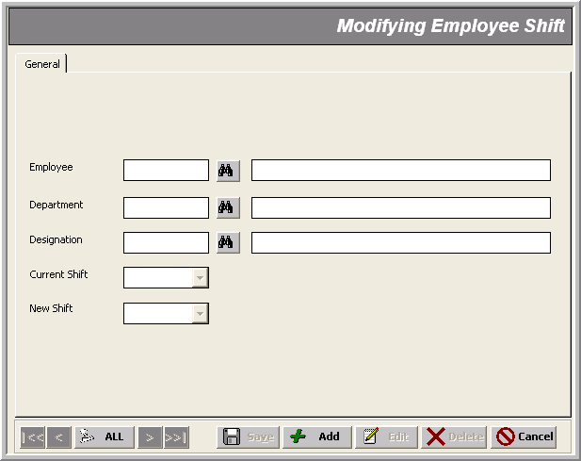

Activity Calendar
_______________________________________________________________________________

Description
This form helps make changes in the ‘Activity Calendar’ generated for all shifts by Shift Master entry.

Note that:
- Shift Master maintains all the information needed about a ‘day’ at FCL for any kind (or shift) of employees; the administrator can, however, over-write a shift activity calendar on a particular day:
- by declaring it a holiday (by just checking the ‘Holiday’ check-box)
- by modifying the type of day form ‘Time Applicable’ combo selection
- All the payroll processing is based on this revised ‘Activity Calendar’.

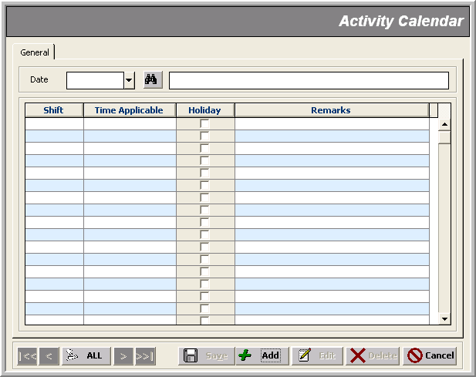

Holiday Calendar
_______________________________________________________________________________

Description
This form helps define yearly holidays with respect to different walks of life.

Note that:
- Declaring a particular date to be a ‘Holiday’ updates the ‘Activity Calendar’ ; i.e. the check-box under ‘Holiday’ columns gets selected (for all shifts) in Activity Calendar setup entry
- If the administrator wants a holiday to remain a working day for some particular shift, he/she will have to ‘un-check’ that ‘Holiday’ tag in Activity Calendar setup entry

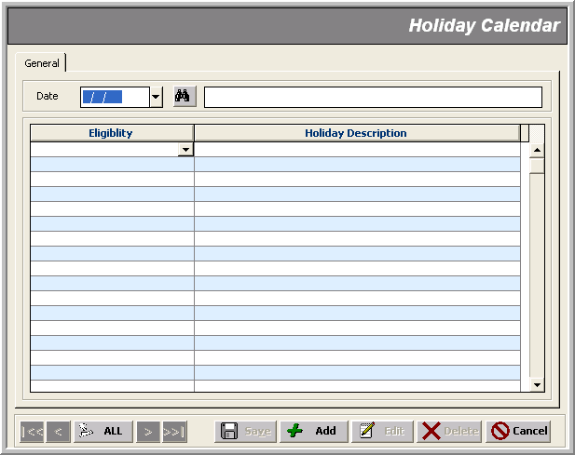

Leave Opening
_______________________________________________________________________________

Description
This form gives totals of current and previous year leaves for an employee.

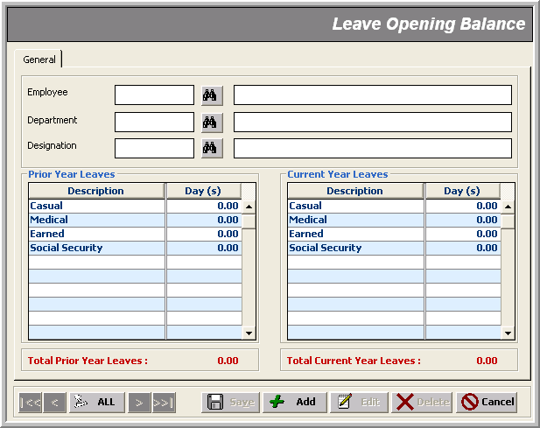

PF Profit
_______________________________________________________________________________

Description
This form is used for specifying current Provident Fund Profit lying in each employee’s account.

Note that:
- This information is for employee’s salary taxation purpose

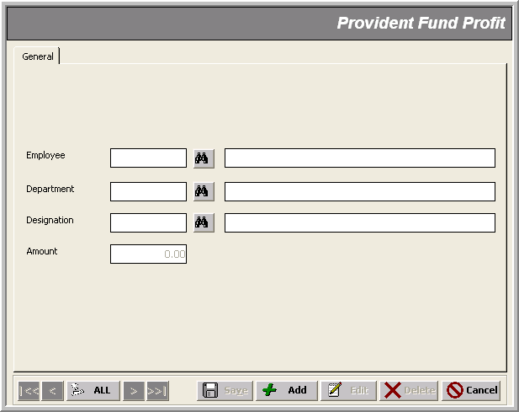

Professional Tax
_______________________________________________________________________________

Description
This form is used for entering Professional Tax to be deducted from an employee’s salary.

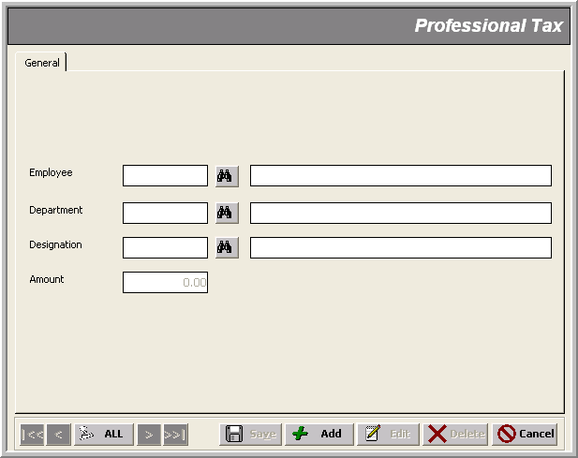

Prior Year WPPF
_______________________________________________________________________________

Description
This form is used to input the amount lying in an employee’s WPP Fund account.

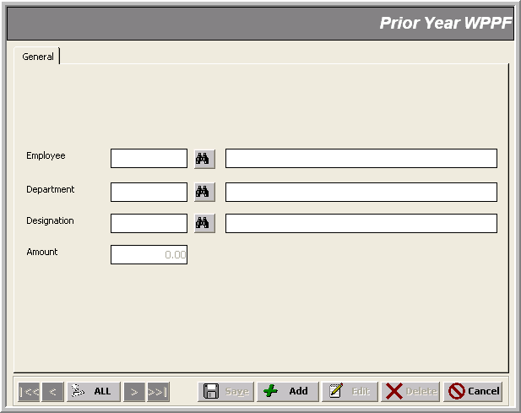

Transactions
_______________________________________________________________________________

FLC Payroll Module transactions can be divided into three main categories:

- Attendance Transactions
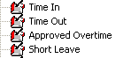
- Leave Transactions
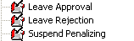
- Payroll Transactions
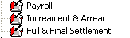

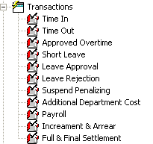 | 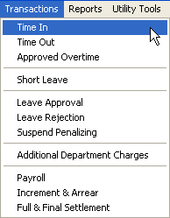

Time In Transactions
_______________________________________________________________________________
Use case: Recording an Employee’s Time-In

Description
This form is used to record an employee’s time-in under the FCL premises, with the following data entry:

- Date
- Type/Nature (<Normal> & <Over Time>)
- Employee info (Code, Shift)
- Location (<Factory> being the default)
- Remarks
- Time-In (with Date)

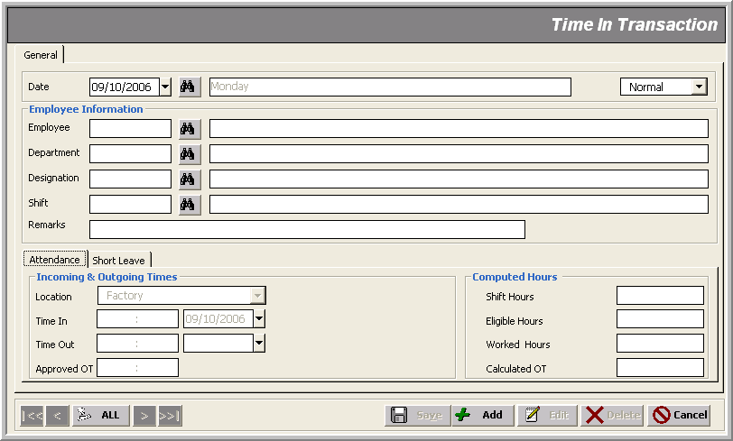

Note that:
- The list of employees to be fetched includes only those employees whose ‘Date Left’ is empty OR ‘Date Left’ lies in the current financial year
- Recording ‘Time In’ of an employee who has long left FCL raises this sort of objection (This is true for other such transactions):
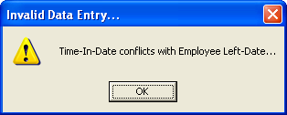
- Only Location and Time-In fields are enabled in the Attendance tab; Short Leave remains disabled
- Here are user specific control options:
Type Shift Time-In Date
For Normal User: Normal not editable not editable
For Administrator/Manager: Normal editable editable
- You can’t enter back date Time-In as compared to the transaction/attendance date:
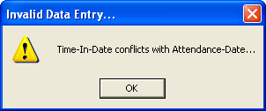
- Time-In transaction of type Overtime implies that there must exist a Normal Time-In transaction; consider the following example for getting the relation of Attendance/Transaction Date, Time-In Date and Type :
Scenario An employee did attend his office ‘normally’; but, then he is called on duty late night at 11:00 pm. (way after his original office/shift timing: say 7:00 am. – 5:00 pm.) He leaves at 2:00 am the same night (which makes his Time-Out on a new day!).
- FCL Attendance System generates this transaction for all employees ‘normally’ using the following default parameters:
Type Shift Location Time-In Date
Normal <employee’s original> Factory <Current Attendance Date>
- It is the administrator who has the control over this information to make any changes; which FCL Attendance System can’t :
- he can make an Overtime transaction
- he can change the shift (if the employee was called on a shift other than his own)
- he can change the location (e.g. Training or Others)
- he can specify a Time-In date other than Attendance Date even in Normal type of
transaction; BUT, the time must lie within the range of:
05:00AM (of attendance date) – 05:00AM (of next day date)
- Violating the above-mentioned constraints related to ‘Time-In hours and date’ makes the system bark:
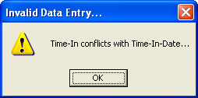
OR
- For a ‘Half Leave transaction’, one must record the corresponding ‘Time-In transaction’ as well; i.e. what time the employee ‘joined his job’ to make it a ‘half day’; similarly before recording a ‘short leave transaction’, a corresponding ‘Time-In transaction’ is a must

- Out of all the three ‘attendance transactions’ only a Time-In transaction could be ‘deleted’ ; but only an administrator has this right

- A normal user has to post all previous un-posted ‘attendance transactions’ before making a ‘Time-In transaction’; an administrator has no such restriction though

- Running a ‘Posting’ process on ‘attendance transactions’ makes them impossible to edit for a normal user

Time Out Transactions
_______________________________________________________________________________
Use case: Recording Employee’s Time-Out

Description
This form is used to record an employee’s time-out under the FCL premises, with the following data entry:

- Date
- Remarks
- Time-Out (with Date)

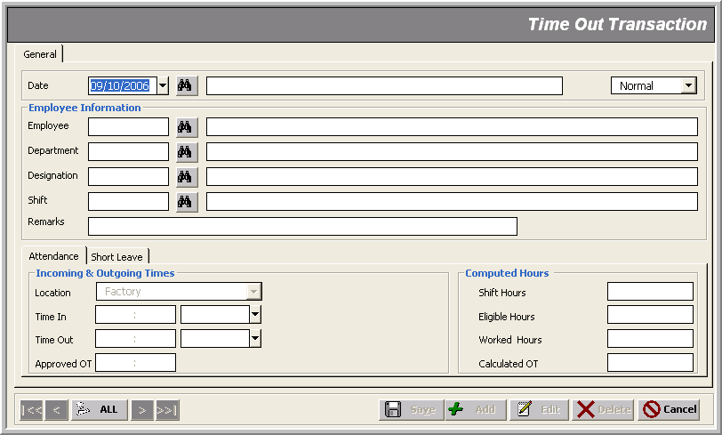

Note that:
- The list of employees to be fetched includes only those employees whose ‘Date Left’ is empty OR ‘Date Left’ lies in the current financial year
- Only Time-Out and Remarks fields are enabled for all users
- You can’t enter back date in Time-Out as compared to the transaction/attendance date; but this ‘Time-Out Date’ could be any no. of days onward
- Time-Out transaction of type Overtime implies that there must exist a Overtime Time-In transaction
- FCL Attendance System generates this transaction for all employees ‘normally’ using the following default parameters:
Type Shift Location Time-Out Date
Normal <employee’s original> Factory <Subject to Shift>
- <Subject to Shift> above means that if a shift spans two different days (e.g. half duty time before 12:00 at night; and another half, after midnight) then the Attendance System automatically recognizes this fact and assigns the ‘Time-Out Date’ that of next day
- Again, it is the administrator who has the right to make an Overtime transaction
- A normal user has to post all previous un-posted ‘attendance transactions’ before making a ‘Time-Out transaction’; an administrator has no such restriction though
- Running a ‘Posting’ process on ‘attendance transactions’ makes them impossible to edit for a normal user

Approved Over Time Transactions
_______________________________________________________________________________
Use case: Recording Employee’s Overtime

Description
This form is used to record an employee’s ‘approved over-time’ on a specific working day under the FCL premises, with the following data entry:

- Date
- Type/Nature (<Normal> & <Over Time>)
- Employee info (Code, Shift)
- Remarks
- Approved OT (Overtime)

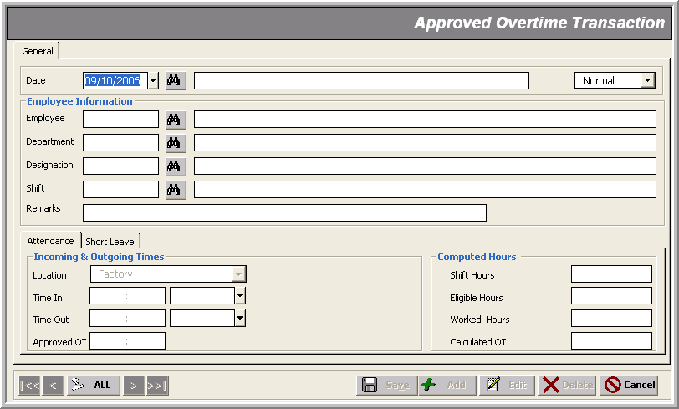

Note that:
- The list of employees to be fetched includes only those employees whose ‘Date Left’ is empty OR ‘Date Left’ lies in the current financial year
- Only Approved OT text box is enabled in the Attendance tab; Short Leave remains disabled
- Here are user specific control options:
Type Shift
For Normal User: Normal not editable
For Administrator/Manager: Normal editable
Overtime
- An ‘Approved Overtime transaction’ of type Normal implies that there must exist Time-In AND Time-out transactions of the same type
- FCL Attendance System can’t handle this type of transaction

Short Leave Transaction _______________________________________________________________________________
Use Case: Recording Employee’s Short Leaves from FCL

Description
This transaction is meant for keeping record of ‘short visits’ that an employee does ‘during’ his/her job hours as part of his/her responsibilities, with the following data entry:

- Document No
- Date
- Employee Info
- Remarks
- One or more leaves/visits of the type: Personal or Official
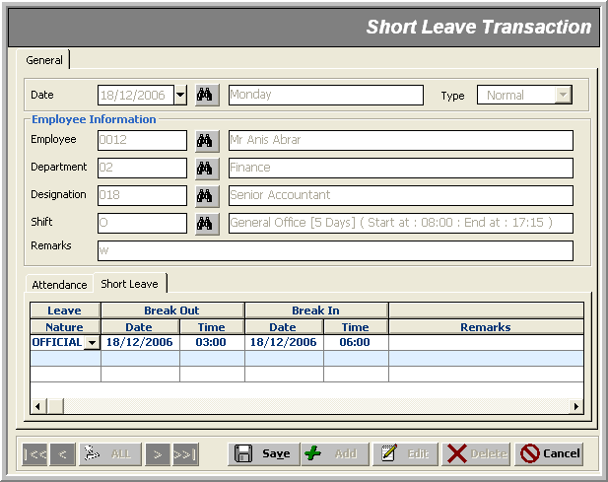

Note that:
- For this transaction, there must exist a corresponding ‘Time-In transaction’ of the same type (i.e. Normal or Overtime); obviously, somebody can’t record his/her ‘short leave absence’ without being checked in:
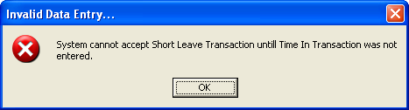

- The list of employees to be fetched includes only those employees whose ‘Date Left’ is empty OR ‘Date Left’ lies in the current financial year
- Only Short Leave tab is enabled to be worked on
- FCL Attendance System can’t handle this type of transaction

Leave Approval Transaction _______________________________________________________________________________
Use Case: Recording Employee’s Approved Leaves

Description
An employee’s leaves are recorded through this form, with the following data entry:

- Document No
- Date
- Employee Info
- Reference No
- Remarks
- One or more leaves of the specified types (within the current available leaves - Online Balance)
This updates the balance of the leaves stats for that employee.

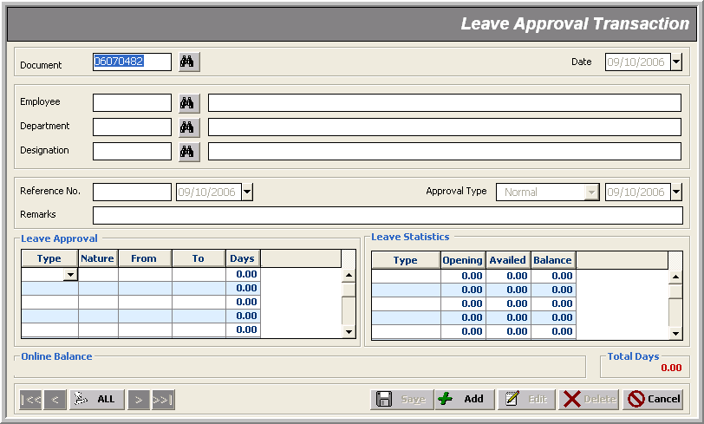

Note that:
- For a new transaction entry, there must not be any ‘Un-Posted Transactions’
- For a normal user, the combo selection tagged ‘Approved Type’ is always ‘Normal’; but it gets populated with some other options for an administrator
- The document gets locked/posted as soon as it is saved away
- There are some obvious validation for the From and To dates of the specified Type of leaves as self-explained by the following alerts:
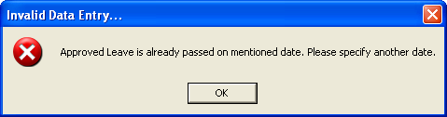
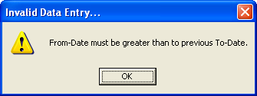
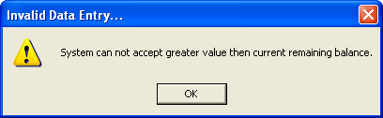
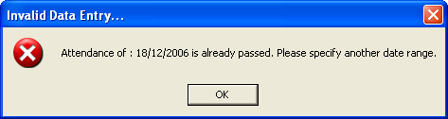

Leave Rejection Transaction _______________________________________________________________________________
Use Case: Canceling an Employee’s Leave

Description
From here an administrator can reject an employee’s leave, with the following data entry:

- Document No
- Date
- Employee Info
- Reference No
- Remarks
- One or more leaves of the specified types
This updates the balance of the leaves stats for that employee. But this stats is not shown on entry time.

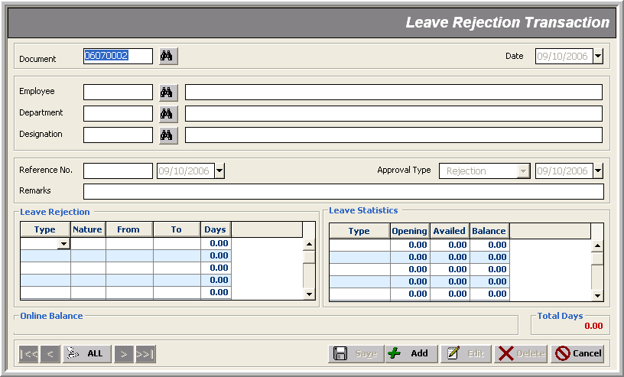

Note that:
- For all users, the combo selection tagged ‘Approved Type’ is always ‘Rejection’
- For a successful rejection of a leave, the following jobs have to be done:
- remove the ‘Leave Approval Transaction’ of that leave after un-posting AND unlocking it from Utility Tools>Un-Posting
- make a ‘Leave Rejection Transaction’ of the same date for the same employee

Suspend Penalizing Transaction _______________________________________________________________________________
Not Implemented Yet!

Additional Department Cost _______________________________________________________________________________
Use Case: Recording Departmental Costs Incurred on a Particular Day

Description
This form is used to record a department’s ‘additional cost’.

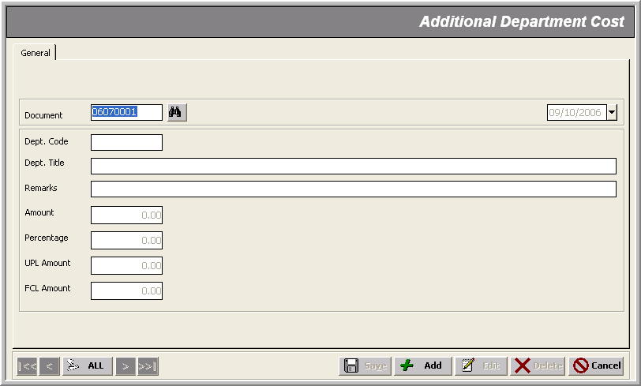

Payroll Transactions ______________________________________________________________________________
Use Case: Making Employee’s Payroll Manually

Description
FCL Payroll is an automated process (see Payroll Generation); though, the administrator can use this form:
- to keep an employee’s payroll up-to-date
- to make any amendment in the auto-generated payroll
- to add/edit the information that the Payroll Generation process can’t ; i.e. some additional ‘deductions’ or/and allowances in the Special tab

Note that:
- FLC Payroll Module is a continuous database of FCL employees; hence, these transactions get employees from FCL HR Module
- For such Payroll Transactions to succeed the following validation must satisfy:
- Trans. Date must lie within the FCL financial year
- Trans. Date must be equal or greater than last transaction (Regular or Arrear)
- There must not be any ‘Un-Posted Transactions’ in back dates (Regular or Arrear)
- Date Left must be empty in the employee record of FCL HR Module

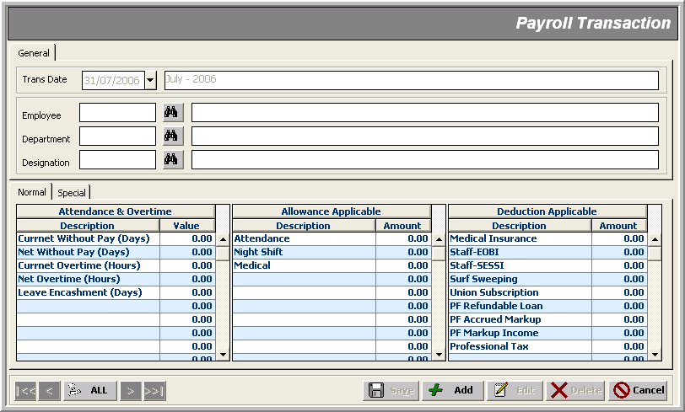

Arrear Transactions ______________________________________________________________________________
Use Case: Making Amendments to an Employee’s Payroll

Description
This form is used to modify an employee’s ‘payroll terms’ based on some increments in his/her salary terms; this is something that the Payroll Generation process can’t do.

Note that:
- FLC Payroll Module is a continuous database of FCL employees; hence, these transactions get employees from FCL HR Module
- For such Payroll Transactions to succeed the following validation must satisfy:
- Trans. Date must lie within the FCL financial year
- Trans. Date must be equal or greater than last transaction (Regular or Arrear)
- There must not be any ‘Un-Posted Transactions’ in back dates (Regular or Arrear)
- Date Left must be empty in the employee record of FCL HR Module
- For Arrear Transactions to succeed, there must not be any ‘Posted Arrear Transactions’ on that Trans. Date
- In case of some ‘un-posted’ transactions lying pending to be ‘full-and-finalized’; invoking this form issues a ‘Notification letter’ (needs review)

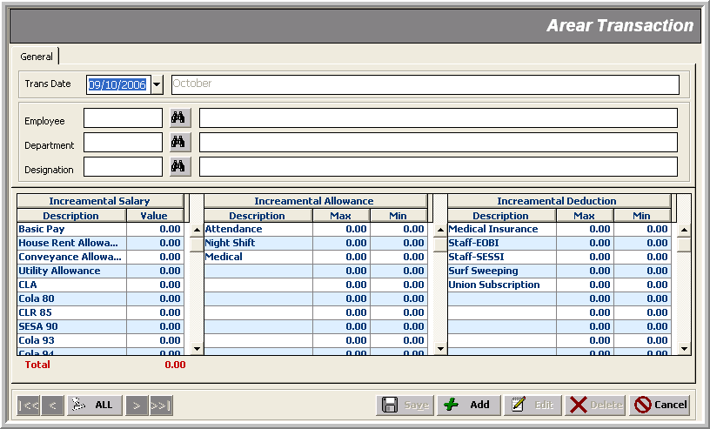

Full & Final Transactions ______________________________________________________________________________
Use Case: Finalizing an Employee’s Payroll

Description
This form is used to finalize an employee’s payroll when he is leaving FCL.

Note that:
- FLC Payroll Module is a continuous database of FCL employees; hence, these transactions get employees from FCL HR Module
- This transaction is only possible when the selected employee’s ‘Date Left’ has been specified through the FCL HR Module; otherwise, the user is notified of this mistake:
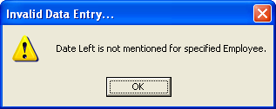
- For such Payroll Transactions to succeed the following validation must satisfy:
- Trans. Date must lie within the FCL financial year
- Trans. Date must be equal or greater than the last transaction (Regular or Arrear)
- There must not be any ‘Un-Posted Transactions’ in back dates (Regular or Arrear)
- Date Left ‘must be empty’ in the employee record of FCL HR Module
- the ‘Encashment Days’ must not exceed the current online balance for that employee
- Full & Final Transactions marks that particular employee record in the FCL HR Module that he is settled down ‘Full & Final’’; hence he/she is not fetched next time for the payroll transactions
- There are some additional items in the Attendance & Overtime as well as Deduction Applicable grid; the calculation rules of the overtime, bonus and PF profit are currently pre-defined in the database; though, they could well be made a part of Setup entries in future so that the administrator himself would be able to control those criteria

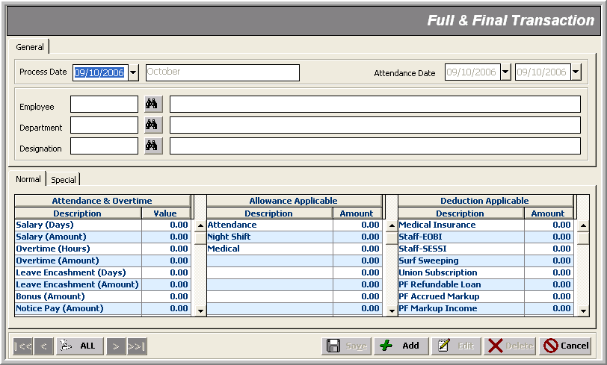

Reports
_______________________________________________________________________________

Utility Tools
_______________________________________________________________________________

Utility Tools cover periodic processes within a closing schedule life-cycle, such as:

- Posting Transactions
- Un-Posting Transactions
- Attendance Generation
- Payroll Generation
- Payroll Processing
- Arrear Processing
- Full & Final Processing
- SESSI Processing
- EOBI Processing
- WPPF Processing
- Encashment Generation
- Yearly Closing

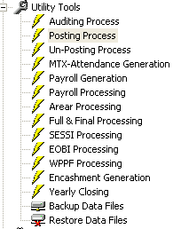 | 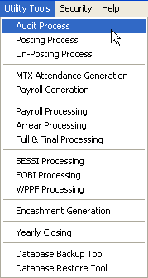

Posting Process _______________________________________________________________________________

Description
Posting Process is performed to Post transactions in non-editable mode to tag them as ‘confirmed’ transactions. It performs the following tasks:

- Runs the ‘Auditing’ process up to date
- Locks all the selected or checked types of transactions for editing

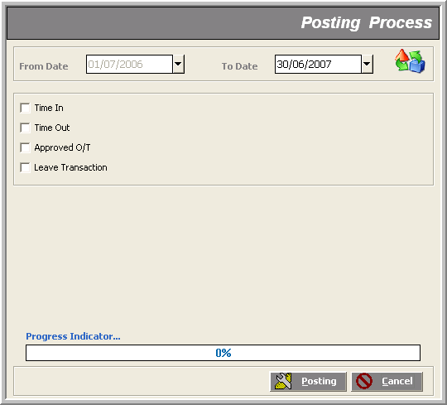

Finally, a message box flags the end of process.

Un-Posting Process _______________________________________________________________________________

Description
Un-posting Process is performed to revert the Posted transactions (with the specified date range and employee parameters) back in editable mode.

Note that:
- If some transaction types are checked AND their respective document no.’s range is provided; it ‘unlocks’ those documents for editing; other wise only first task is done

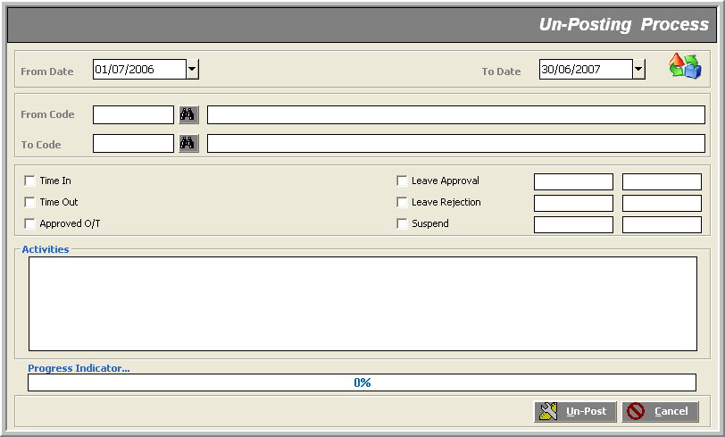

Attendance Generation Process _______________________________________________________________________________

Description
By this process, FCL Attendance System gets invoked which starts transferring attendance data logged by FCL Machine to the system’s main database.

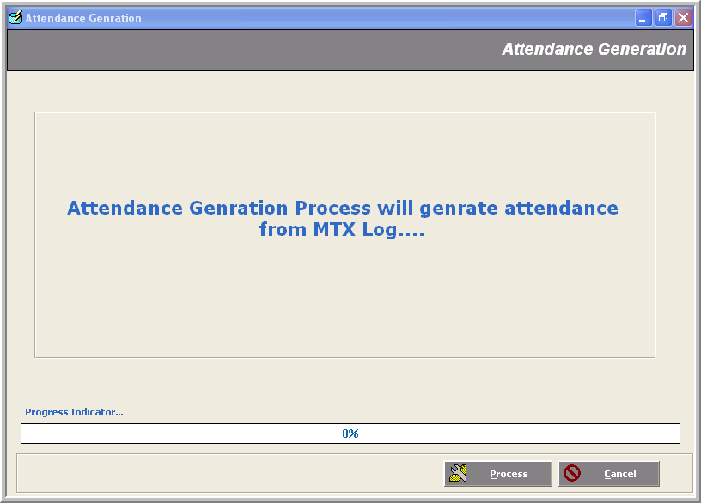

Generation Payroll Transaction _______________________________________________________________________________

Description
This process is used to generate Payroll Transactions for all employees with the specified parameters

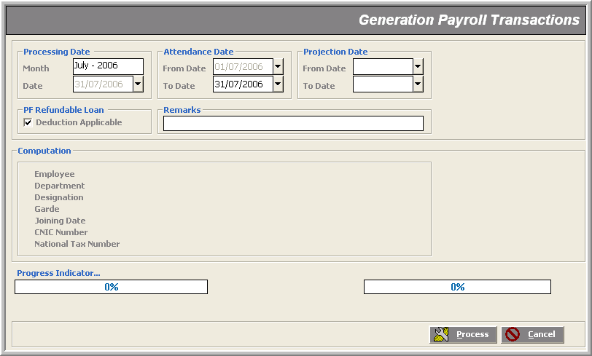

Payroll Process Transaction _______________________________________________________________________________

Description

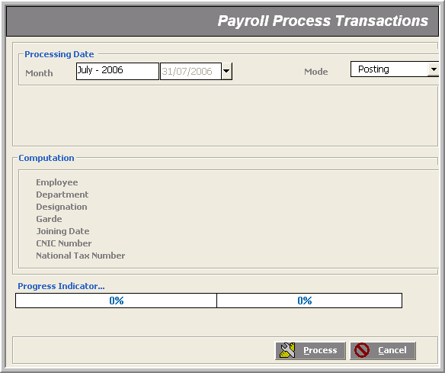

Arrear Processing _______________________________________________________________________________
Description

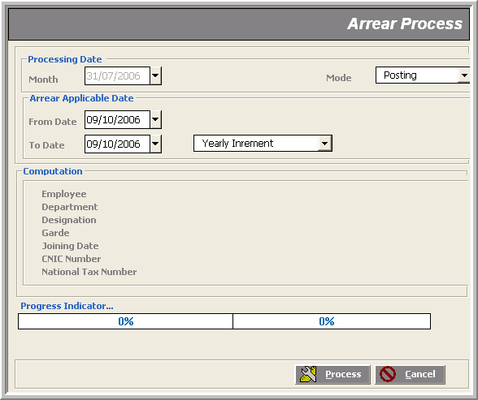

Full & Final Processing _______________________________________________________________________________

Description

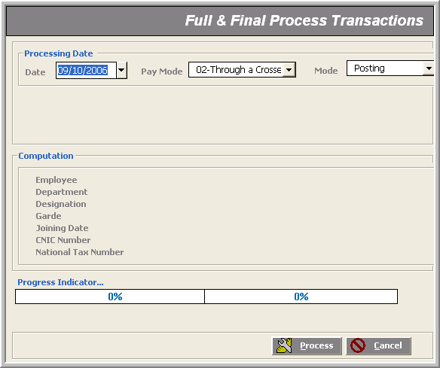

SESSI Processing _______________________________________________________________________________

Description
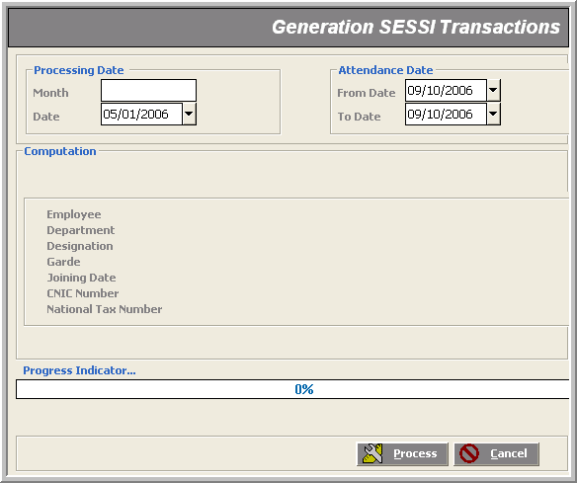

EOBI Processing _______________________________________________________________________________

Description

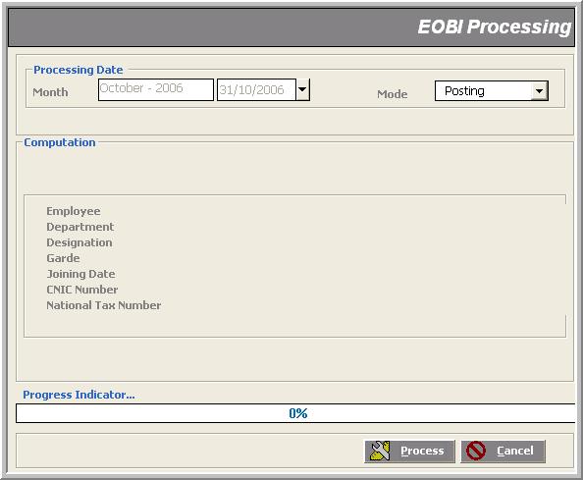

WPPF Processing _______________________________________________________________________________

Description

Encashment Generation _______________________________________________________________________________

Description

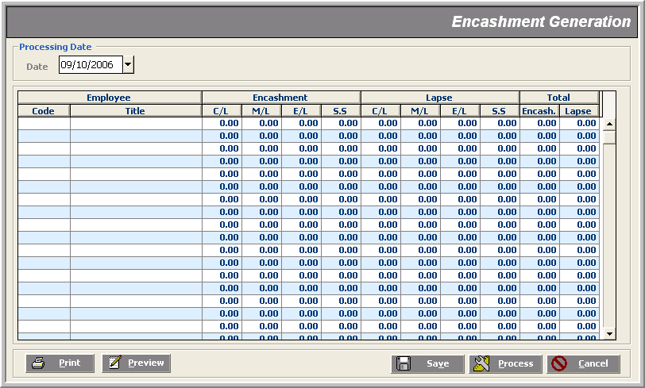

Yearly Closing _______________________________________________________________________________

Description

